**Ibrahim Siddiqi (7352396), Riva Pereira (7839078), Majd ( 7068980 )**

**Executive Summary**

This project aims to explore and analyze the Adult Income dataset using advanced clustering techniques and data visualization methods. The dataset, which includes various demographic and income-related attributes, was subjected to a rigorous process of data cleaning, preprocessing, and clustering to uncover hidden patterns and insights.

**Key Steps and Findings**

**Data Loading and Preprocessing:**

The dataset was imported, and missing values were handled by replacing them with NA and removing incomplete rows.

The data was split into numeric and categorical subsets to facilitate targeted preprocessing.

Categorical variables were converted to numeric using one hot encoding, and all features were standardized through scaling.

**Initial Data Exploration:**

Basic visualizations, such as scatter plots and smooth lines, were created to explore relationships between variables like age and hours worked per week.

These preliminary analyses provided a foundation for more complex clustering methods.

**Clustering Techniques:**

K-Means Clustering: Applied to the dataset to identify distinct groups within the data. The elbow method, gap statistic, and silhouette method were used to determine the optimal number of clusters.

Hierarchical Clustering: Performed on a smaller sample due to computational complexity, with dendrograms and heatmaps used for detailed visualization.

Model-Based Clustering: Utilized Gaussian Mixture Models to identify clusters based on statistical methods.

Density-Based Clustering (DBSCAN): Implemented to find clusters based on data density, with epsilon values chosen through k-nearest neighbors distance plots.

**Visualization of Clustering Results:**

Various visualizations, including scatter plots with density shading, box plots, and scatter plots with ellipses, were created to illustrate the clustering results and reveal patterns in the data.

These visualizations helped to understand the distribution and characteristics of each cluster, highlighting relationships between different demographic and income-related variables.

**Insights and Conclusions**

The clustering analysis revealed several key insights:

Age and Work Hours: Clear patterns emerged showing how working hours varied with age, with different clusters exhibiting distinct characteristics.

Marital Status and Age: Box plots highlighted relationships between age and marital status across different clusters.

Race and Native Country: Scatter plots with ellipses showed the distribution of race and native country, revealing cluster-specific patterns.

Occupation and Work Hours: Relationships between occupation and hours worked per week were visualized, providing insights into work habits across different clusters.

**Loading the Dataset**

The dataset is loaded into R using the read.csv function. The na.strings parameter is used to handle missing values represented by " ?". The dataset is initially inspected using head, summary, and str functions to understand its structure and contents.



**Assigning Column Names**

The dataset does not come with predefined column names. A vector containing the appropriate column names is created and assigned to the dataset for clarity and better readability.

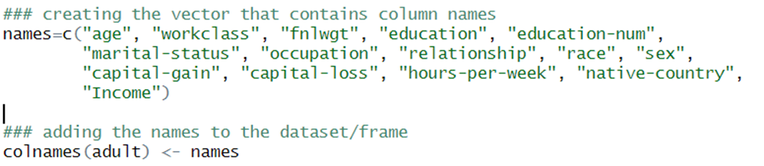

**Handling Missing Values**

Missing values are a common issue in real-world datasets. In this project, missing values are replaced with NA and rows containing NA values are removed to ensure the integrity of the data analysis.

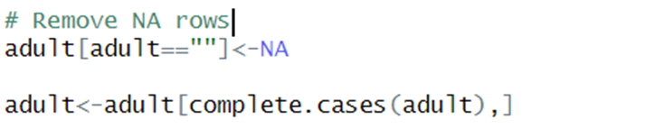

**Separating Data into Numeric and Categorical Subsets**

To facilitate targeted preprocessing and analysis, the dataset is divided into numeric and categorical subsets.

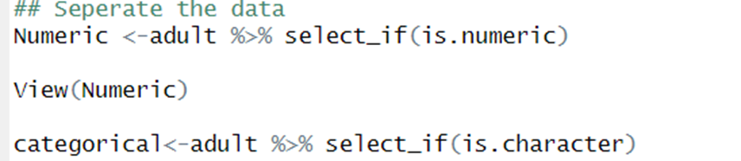

###### **Initial Visualizations**

Basic visualizations are created to explore the relationships between numeric variables. For instance, scatter plots and smooth lines are used to examine the relationship between age and hours worked per week.

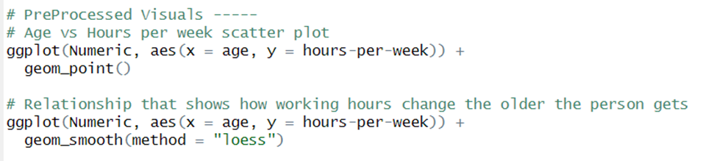

According to the graphs (Kept in Interpretation),

**Clustering Analysis**

One Hot Encoding and Scaling

Categorical variables are converted to numeric format using one hot encoding. This process involves creating binary columns for each category. After one hot encoding, all data is scaled to standardize the range of features, which is essential for many machine learning algorithms.

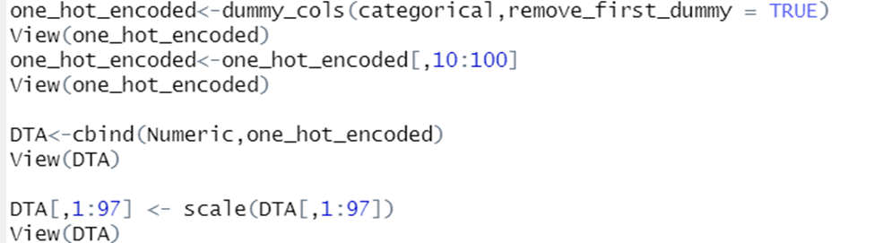

**Sample Creation**

Due to computational constraints, a sample of 2000 rows is selected from the scaled dataset for clustering analysis.

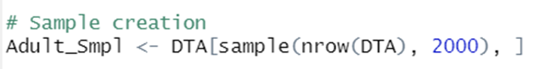

**K-Means Clustering**

Determining the Optimal Number of Clusters

The K-means algorithm requires specifying the number of clusters. To determine the optimal number of clusters, the methods wss, gap statistic, and silhouette method are used.

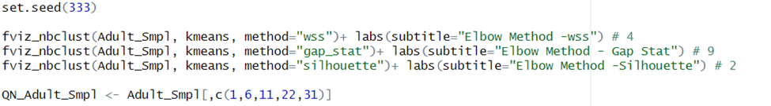

The visualization of Wss, Gapstat, and Sihouette draws me to the conclusion that the number of clusters (k) would be 2, so throughout this analysis k would be used as 2 as it is the most ideal k.

**Applying K-Means Clustering**

Based on the results of the clustering methods, K-means clustering is applied with the chosen number of clusters. The clustering results are visualized to understand the distribution and characteristics of each cluster.

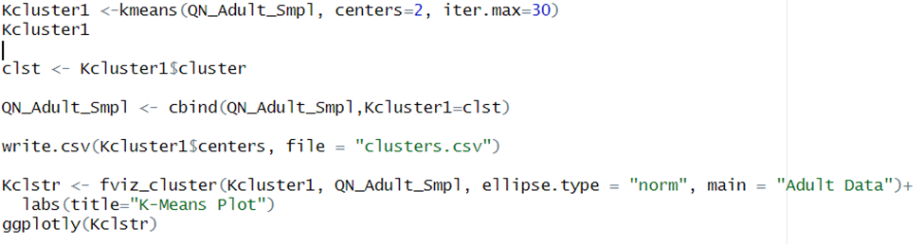

According to Kmeans Visualization plot, The Clusters seem to be visualized in two central clusters with not many outliers.

###### 

###### 

###### **Analysis**



According to my observation, there seem to be two significant groups in the data.

Those who are young, have less education and are married compared to those who are older, with more hours into work, have more education and are not married.

While going through the clustering distribution of the data

(Age vs Education_Doctorate)

The Age distribution suggests there is a higher concentration of more established professionals with doctorates compared to those who are early in their careers

(Age vs Hours Per Week)

There is a correlation between Age and Hours Worked, which means the older the person is the more hours they put into their job.

From here, I can explain that as people grow and progress slowly in their careers they take on more positions and higher roles. They would seek financial stability and career progression.

While people who are younger they’d take up more free-lance positions to build up their portfolios and according to the clustering, would be more considering work-life balance and family planning at their age.

Questions Answered-

**Does the data suggest there might be a trade-off between work hours and career advancement for younger workers?**

The younger cluster with more sporadic hours might indicate that some younger workers prioritize work-life balance, potentially affecting the number of hours they dedicate to their careers initially.

**What’s the reasons between age and work hours related to career progression in your data?**

Older workers putting in more hours might be associated with taking on more responsibilities and higher roles, leading to a need to dedicate more time to their jobs.

**How are individuals from different races distributed across various native countries, and how do these distributions relate to different clusters?**

(Refer to The Scatter plot for Race and Native Country with Cluster Shading.)

The scatter plot visualizes the relationship between race and native country, with data points colored by clusters. This helps to identify patterns and distributions across different clusters based on race and native country.

**How do the hours worked per week vary across different occupations-?**

Refer to the Scatter plot for Hours Per Week and Occupation with Cluster Shading.

The scatter plot shows the relationship between hours worked per week and occupation, with data points colored by clusters. This plot helps to identify patterns in work hours across different occupations and clusters.

**Hierarchical Clustering**

Hierarchical clustering is performed on a smaller sample due to its computational complexity. A dendrogram is plotted to visualize the clusters, and heatmaps are used to provide a detailed view of the clustering structure.

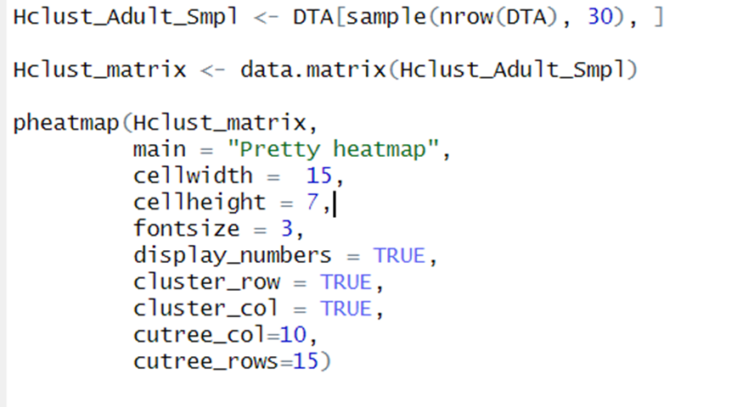.

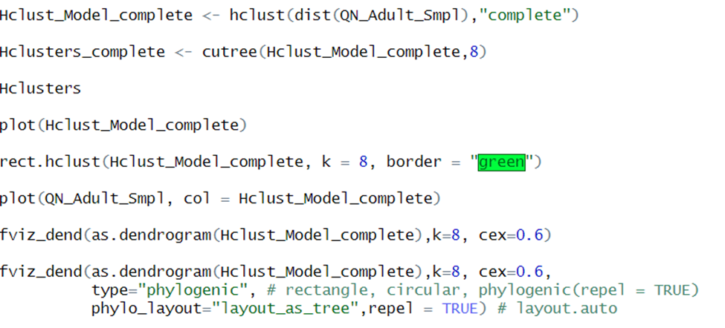

**Model-Based Clustering**

A Gaussian Mixture Model is applied to the sample data using the Mclust package. This model-based clustering approach uses statistical methods to identify clusters in the data.

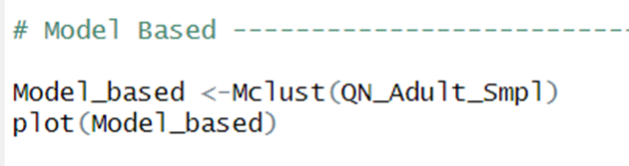

**Density-Based Clustering (DBSCAN)**

The DBSCAN algorithm is used to identify clusters based on density. An epsilon value is chosen after inspecting the k-nearest neighbors distance plot.

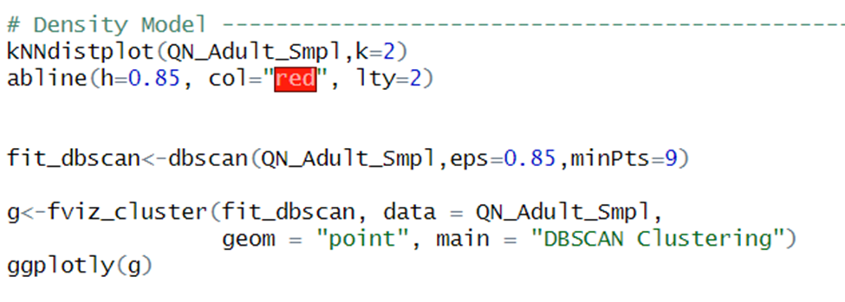

**Visual Patterns**

To further understand the clustering results, various visualizations are created. These include scatter plots, box plots, and density plots, which help to reveal the relationships between clusters and different features in the dataset.

**K-Means Visualization**

The results of the K-means clustering are visualized to identify patterns in the data. Different visualizations such as scatter plots with density shading, box plots, and scatter plots with ellipses are created.

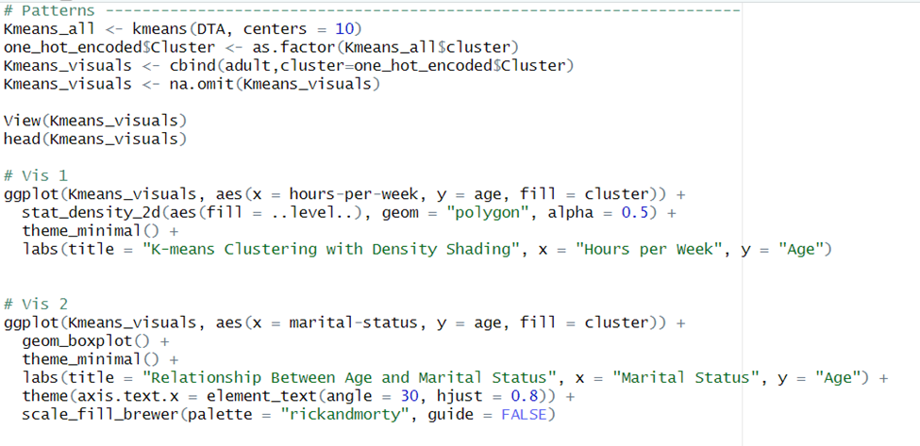

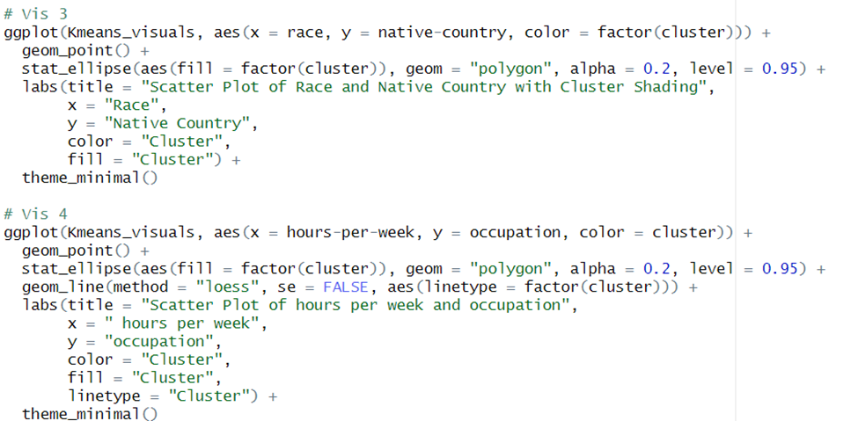

### Interpretation (For now so I can see it)

Ggplot (Hours per Week vs Age)

#### 

The plot shows that as age increases from the lower end (e.g., early 20s), the average hours worked per week also increases. This trend continues up to around the mid-40s. This could indicate that individuals in their prime working years (mid-20s to mid-40s) tend to work more hours per week, possibly due to career growth, stability, and fewer personal responsibilities compared to younger ages. Around the age of 45, the hours worked per week appear to peak. This suggests that individuals in their late 40s might be at the height of their careers, taking on significant responsibilities that demand more work hours. After the peak, the plot shows a gradual decrease in hours worked per week as age continues to increase beyond 45. This trend continues until around the age of 60. This decline might reflect a shift towards less demanding roles, partial retirement, or changes in job types that require fewer working hours as individuals approach the retirement age. After the age of 60, there is a significant drop in hours worked per week. This is likely due to retirement, semi-retirement, or a transition to part-time work.

##### Elbow Method - Wss

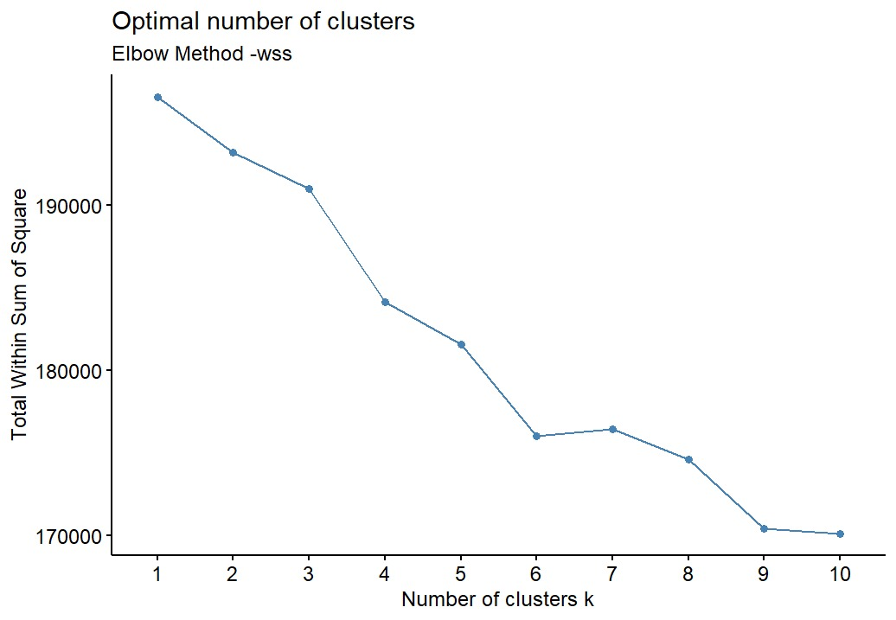

##### Elbow Method- Gapstat

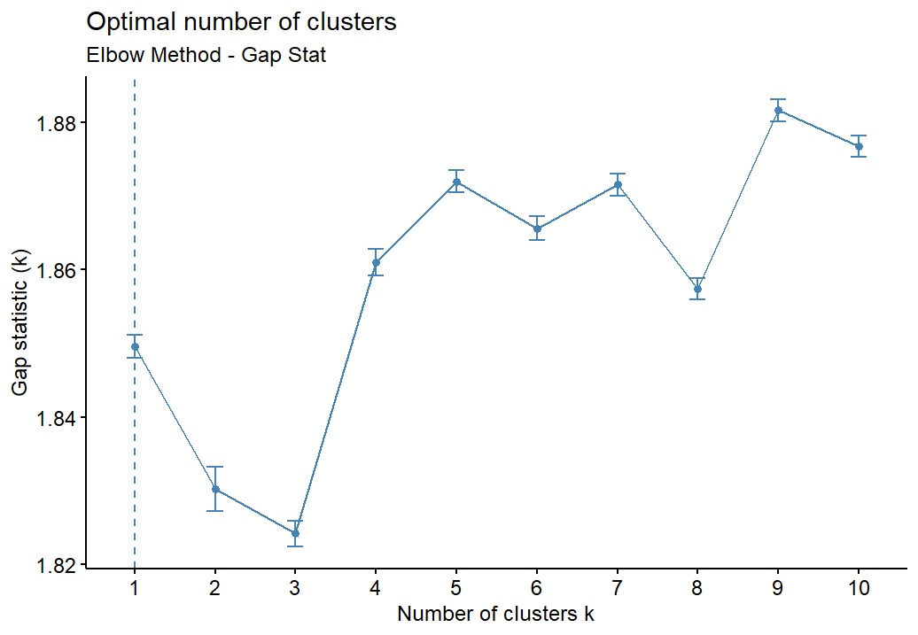

##### Elbow Method- Silhouette

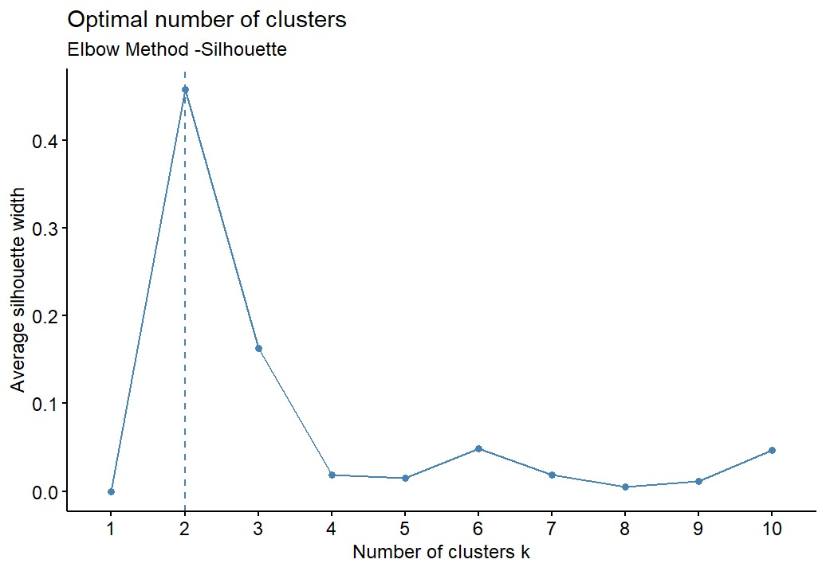

##### Kmeans Visualization Plot

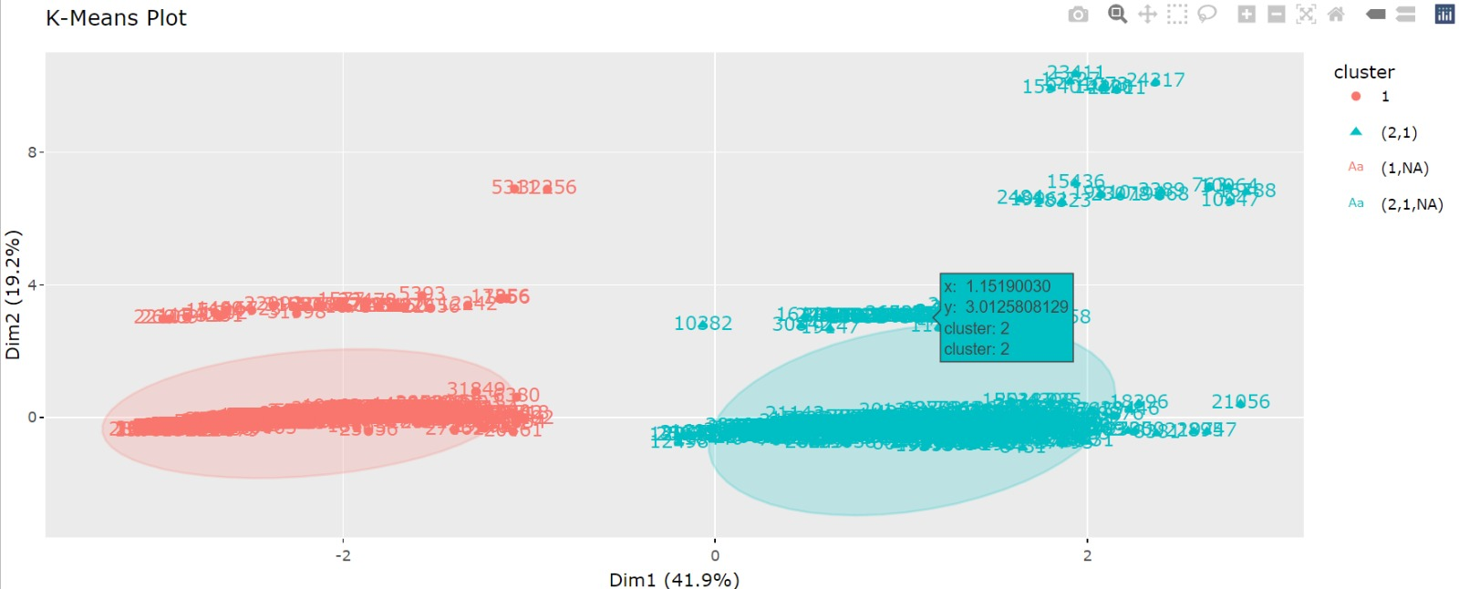

##### Age vs Education_Doctorate

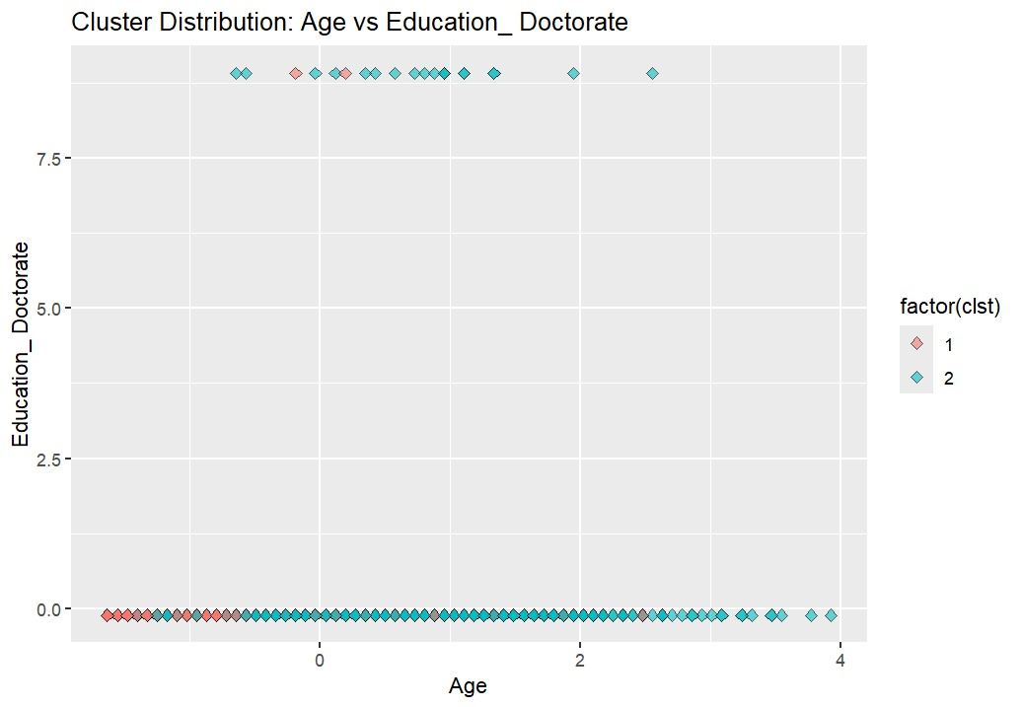

##### Age vs Hours Per Week

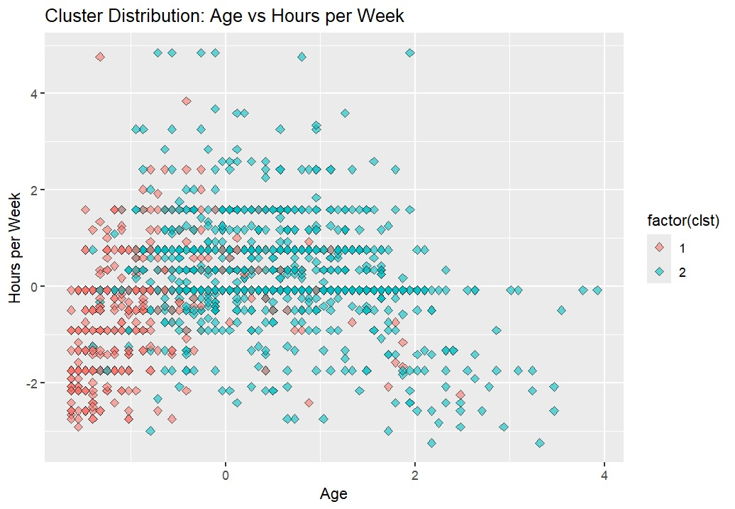

**Cluster Distribution:**

**Cluster 1: Data points in Cluster 1 (red) are primarily concentrated in the lower left quadrant of the plot. This suggests that individuals in this cluster tend to be younger and work fewer hours per week.**

**Cluster 2: Data points in Cluster 2 (blue) are more widely spread across the plot, covering a broader range of ages and hours worked per week. This indicates that this cluster includes individuals of various ages who work varying hours per week.**

**Age Patterns:**

**Younger Individuals: There is a noticeable concentration of younger individuals (left side of the X-axis) in Cluster 1, indicating that younger individuals tend to belong to this cluster and work fewer hours per week.**

**Older Individuals: Cluster 2 shows a broader age range, including both younger and older individuals.**

**Work Hours Patterns:**

**Fewer Hours: Individuals who work fewer hours per week (lower part of the Y-axis) are predominantly in Cluster 1.**

**More Hours: Individuals who work more hours per week (upper part of the Y-axis) are mostly in Cluster 2, which also includes those working standard full-time hours.**

##### Pretty HeatMap

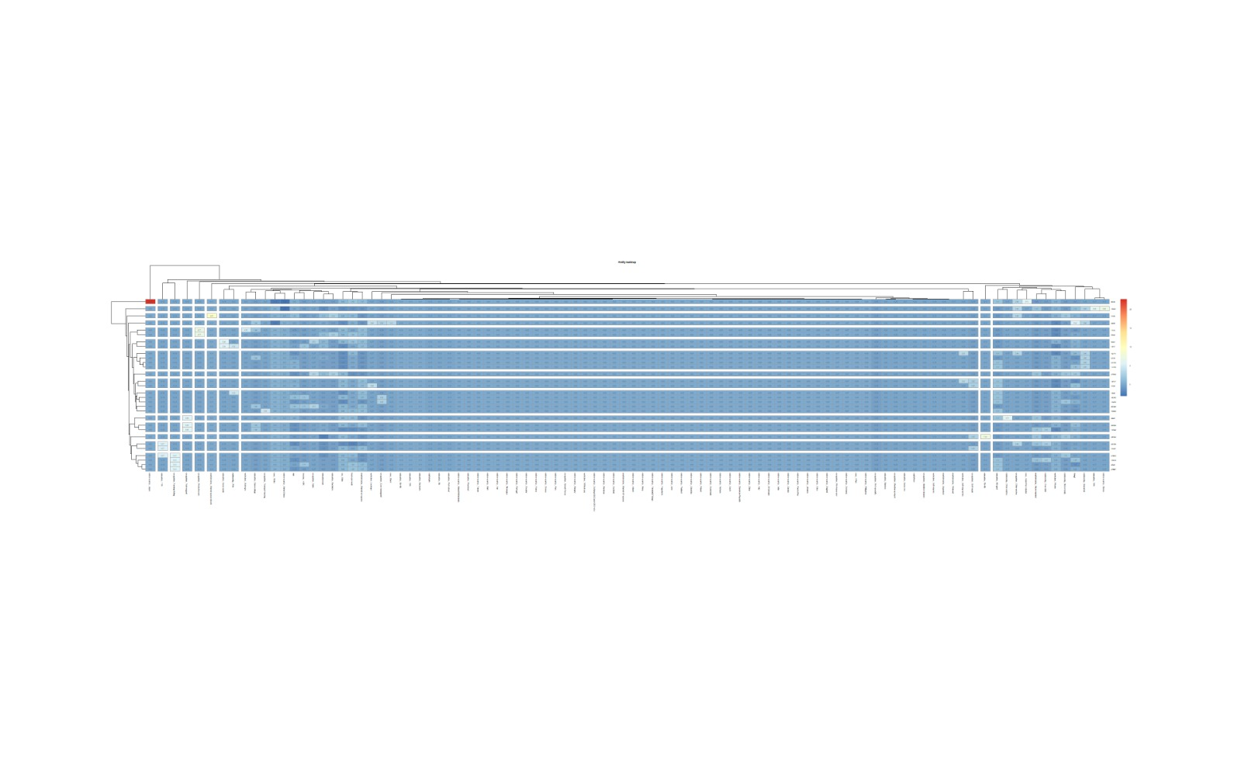

##### Cluster Dendrogram

##### Hcluster Model Viz

##### Cleaned up Dendogram

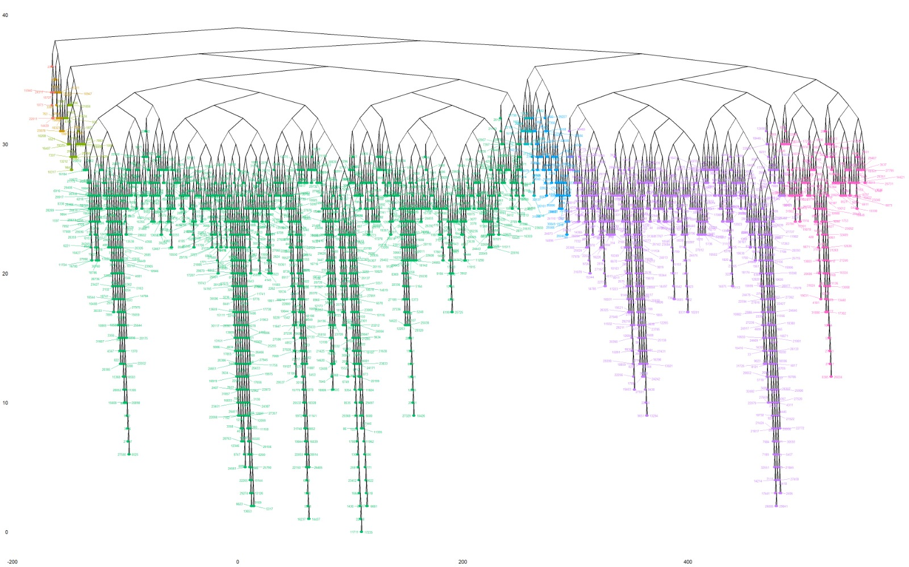

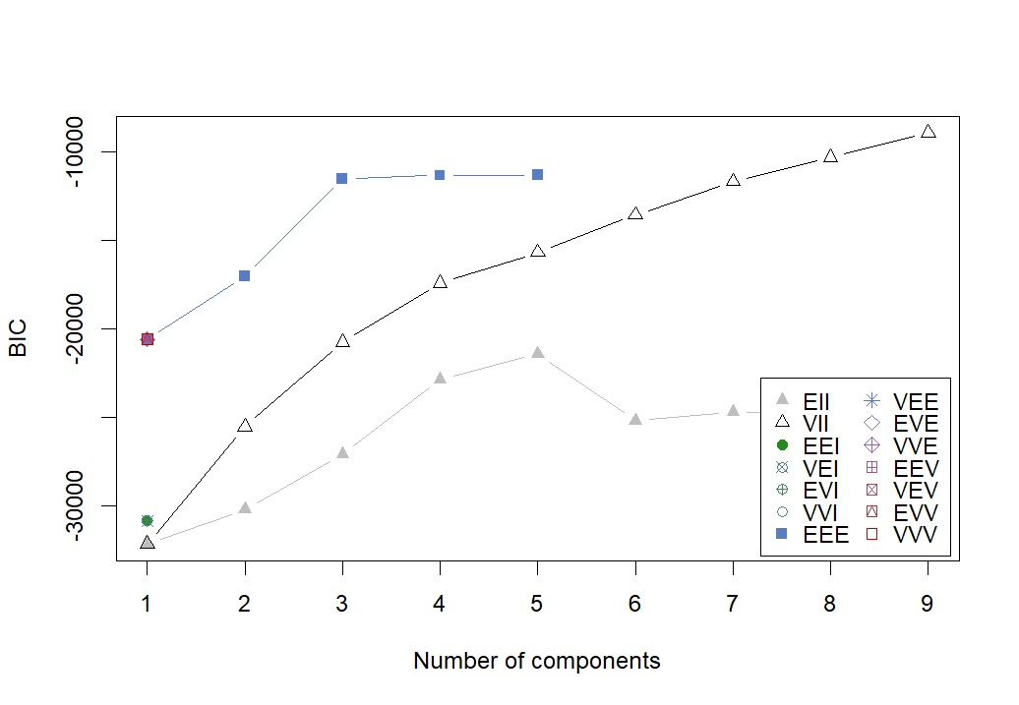

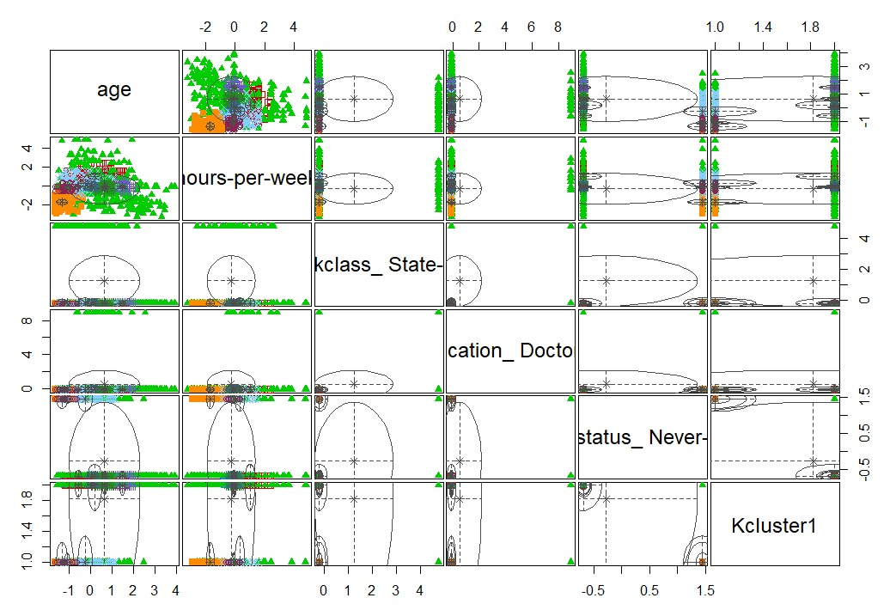

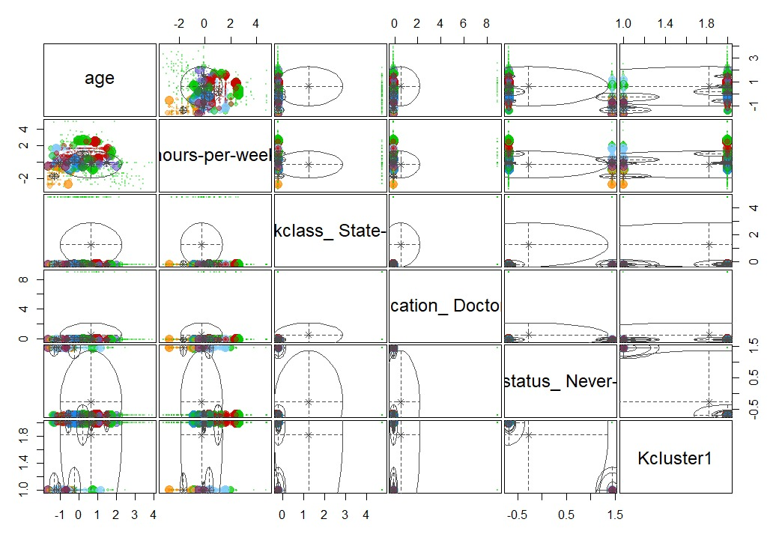

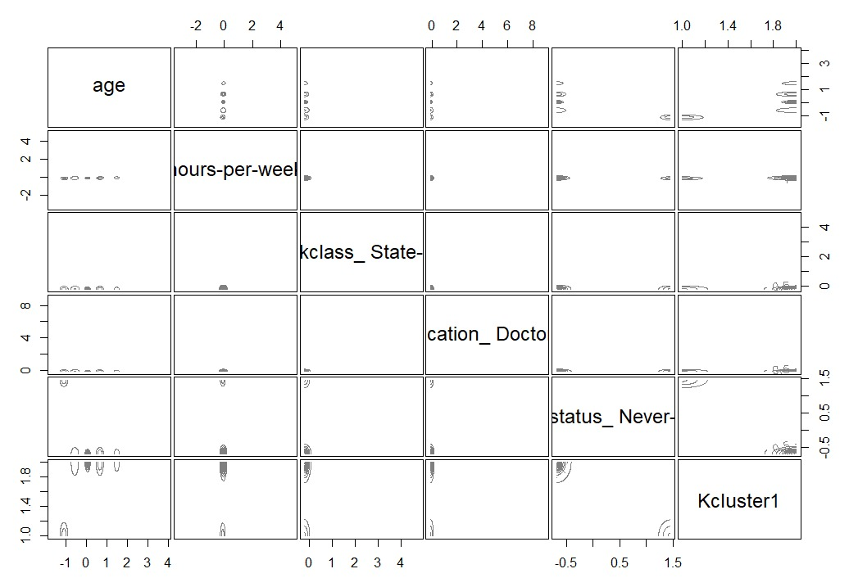

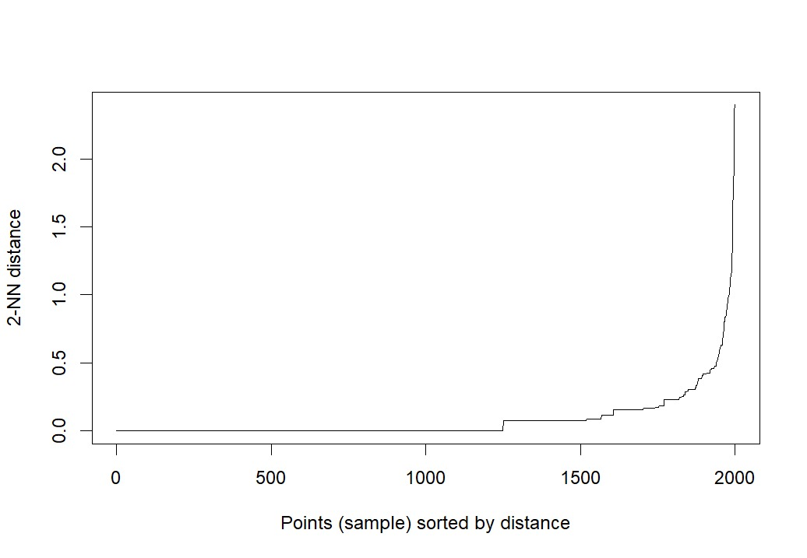

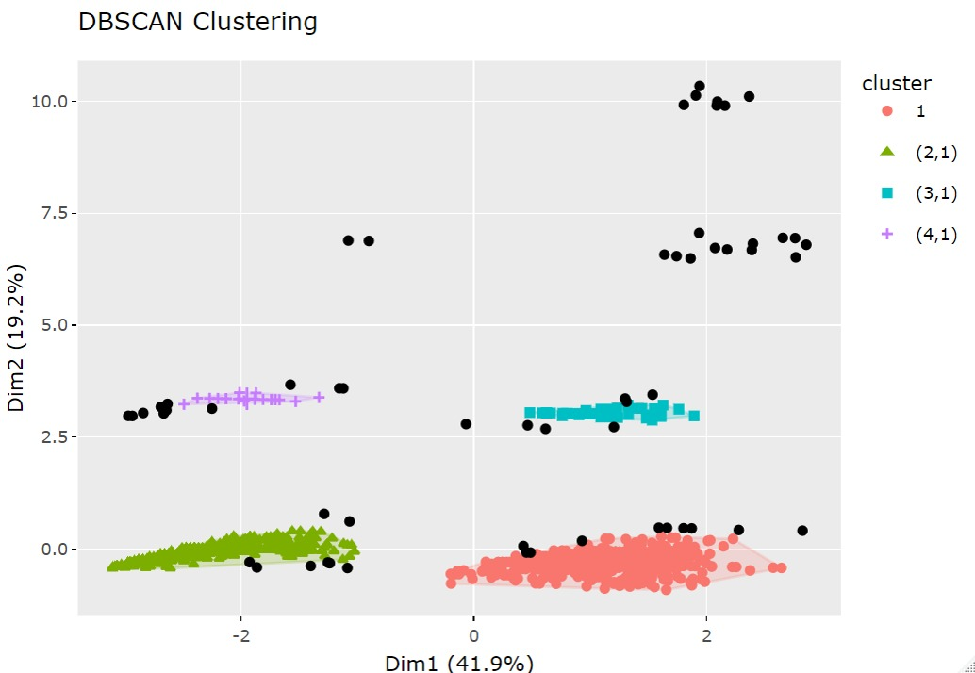

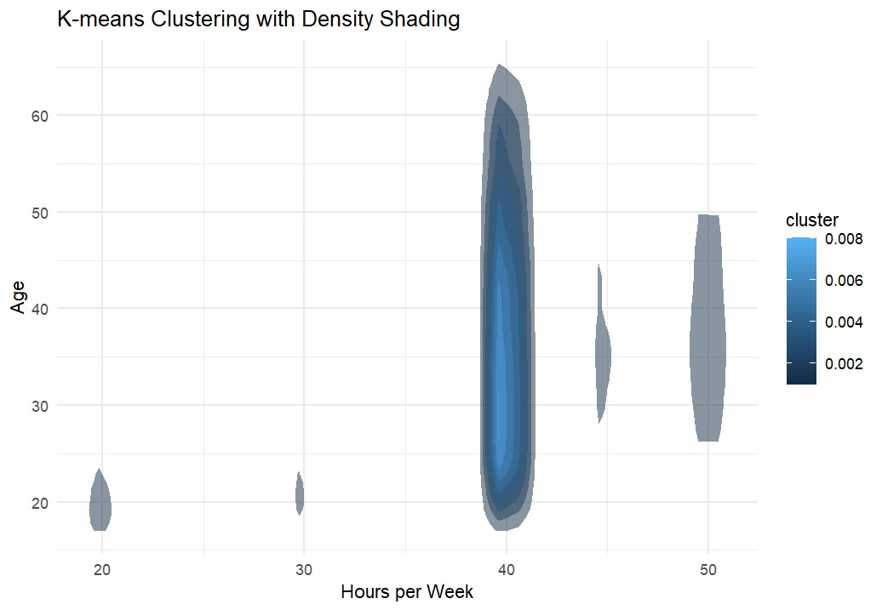

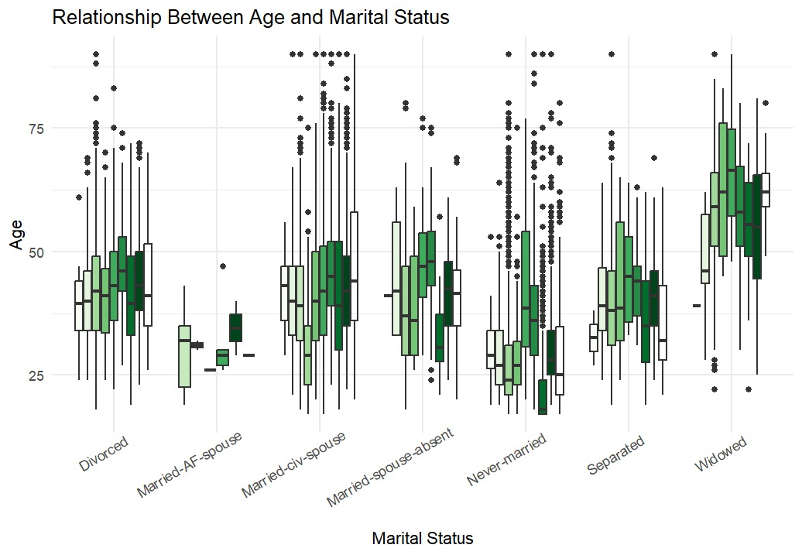

**Divorced:**

**The age distribution for divorced individuals spans a wide range, with a median age around the mid-40s. There are several outliers at both younger and older ages.**

**Married-AF-spouse:**

**This category has a narrower age range, with most individuals clustered around a younger median age compared to other married categories.**

**Married-civ-spouse:**

**This group has a broad age distribution, with a median age in the mid-40s. The interquartile range (IQR) is wide, indicating significant variability in age. There are also many outliers, particularly at older ages.**

**Married-spouse-absent:**

**The age distribution here is narrower, with the median age around the early 30s. The spread is less compared to the married-civ-spouse category.**

**Never-married:**

**This group shows a concentration of younger individuals, with a median age in the mid-20s. The spread is relatively narrow, with fewer older individuals and more outliers on the younger side.**

**Separated:**

**The age distribution for separated individuals has a median age in the mid-30s. The IQR is moderate, with some outliers present, especially at older ages.**

**Widowed:**

**This category has a higher median age compared to other groups, typically around the late 60s. The distribution is skewed towards older ages, with many individuals in their 70s and 80s.**

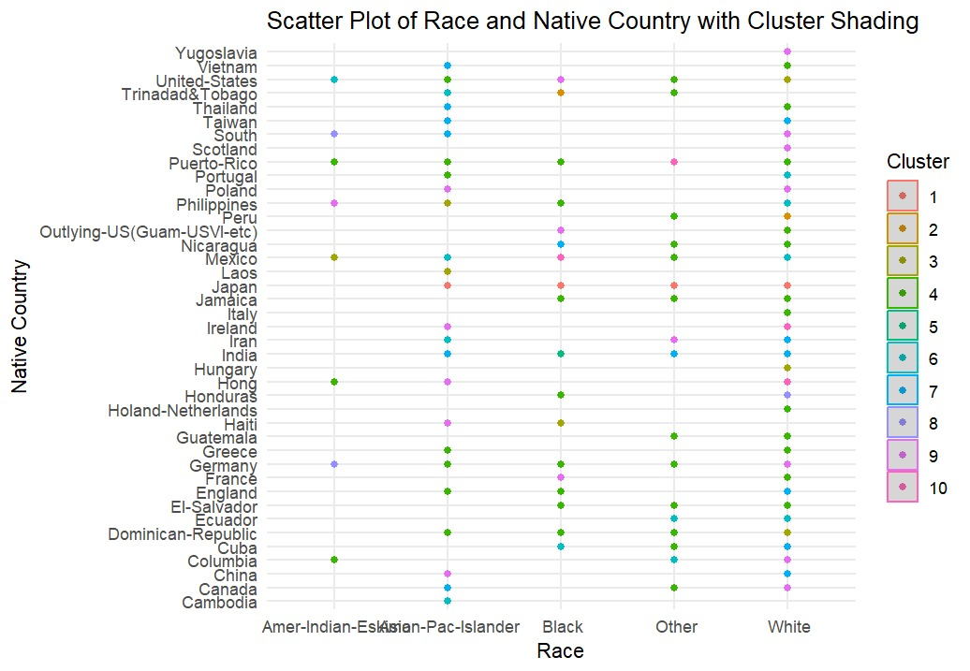

**Distribution of Clusters:**

**Each dot on the plot represents an individual, colored according to the cluster they belong to. The plot allows for the visualization of how individuals from different races and native countries are distributed across clusters.**

**Patterns within Racial Categories:**

**White: This category has the most diverse representation across clusters, with data points spread across almost all clusters. This indicates that individuals identified as White come from a variety of native countries and belong to multiple clusters.**

**Asian-Pac-Islander: This category also shows a spread across multiple clusters, although it appears less diverse compared to the White category.**

**Black, Amer-Indian-Eskimo, and Other: These categories have fewer data points and are distributed across fewer clusters, indicating a more concentrated distribution.**

**Patterns within Native Countries:**

**United States: Individuals from the United States are distributed across many clusters, indicating diverse racial representation and clustering within this group.**

**Other Countries: Some countries, especially those with fewer data points (e.g., Cambodia, Peru, Yugoslavia), show a more concentrated clustering, often appearing in specific clusters.**

**Clusters by Region: There are visible patterns where certain clusters might represent specific regions or countries more heavily. For example, clusters 2, 4, and 7 might have a higher representation of individuals from Asian countries.**

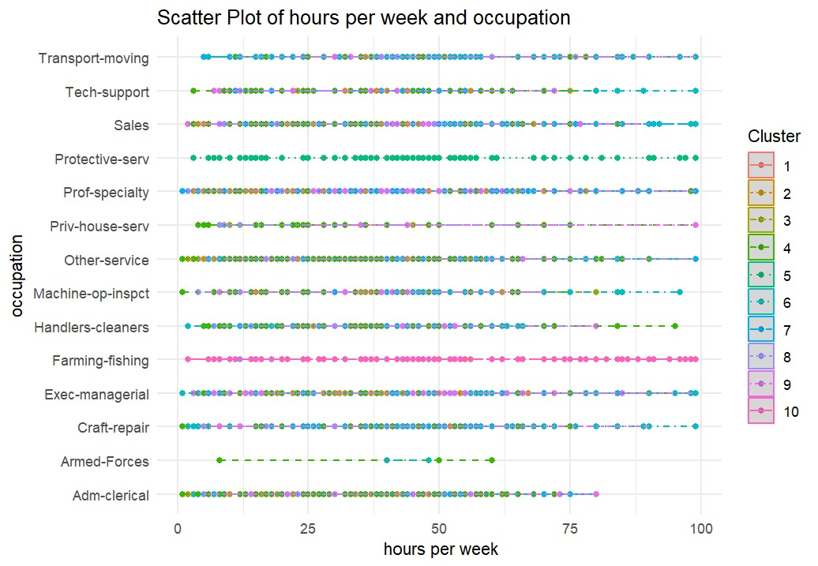

**Distribution of Clusters Across Occupations:**

**Each dot represents an individual, colored according to their cluster. The plot shows how individuals from different occupations are distributed across various clusters.**

**Prof-specialty and Exec-managerial: These categories show a wide range of hours worked per week and a diverse spread across multiple clusters, indicating varied work patterns and diverse clustering within these occupations.**

**Armed-Forces and Protective-serv: These categories have more concentrated distributions, with data points clustered around specific hours per week, showing more homogeneous work patterns.**

**Adm-clerical, Sales, and Tech-support: These occupations show moderate diversity in hours worked and clustering patterns, indicating some variation in work hours and cluster distribution.**

**Patterns of Work Hours:**

**Lower Hours Per Week (0-25 hours): This range includes occupations such as Priv-house-serv and Other-service, where individuals work fewer hours. These categories show clustering in lower-hour ranges.**

**Standard Full-Time Hours (35-45 hours): Many occupations, including Adm-clerical, Tech-support, and Sales, show a concentration of data points in this range, indicating standard full-time work hours.**

**Higher Hours Per Week (50+ hours): Occupations such as Exec-managerial and Prof-specialty have individuals working more extended hours, showing clustering in higher-hour ranges.**

**Cluster-Specific Insights:**

**Cluster 1 and Cluster 2: These clusters appear across multiple occupations and show varying work hours, indicating diverse work patterns and occupations.**

**Cluster 9 and Cluster 10: These clusters have fewer data points and are more concentrated in specific occupations or hours worked, indicating less diversity within these clusters.**

**Conclusion**

This project demonstrates the complete process of loading, preprocessing, and analyzing the Adult Income dataset using various clustering techniques. By applying K-means, hierarchical, model-based, and density-based clustering, we identified different patterns and insights within the data. The visualizations provided clear and intuitive representations of these patterns, facilitating a better understanding of the relationships between different variables. This comprehensive analysis can serve as a foundation for further studies and applications in data science and machine learning.